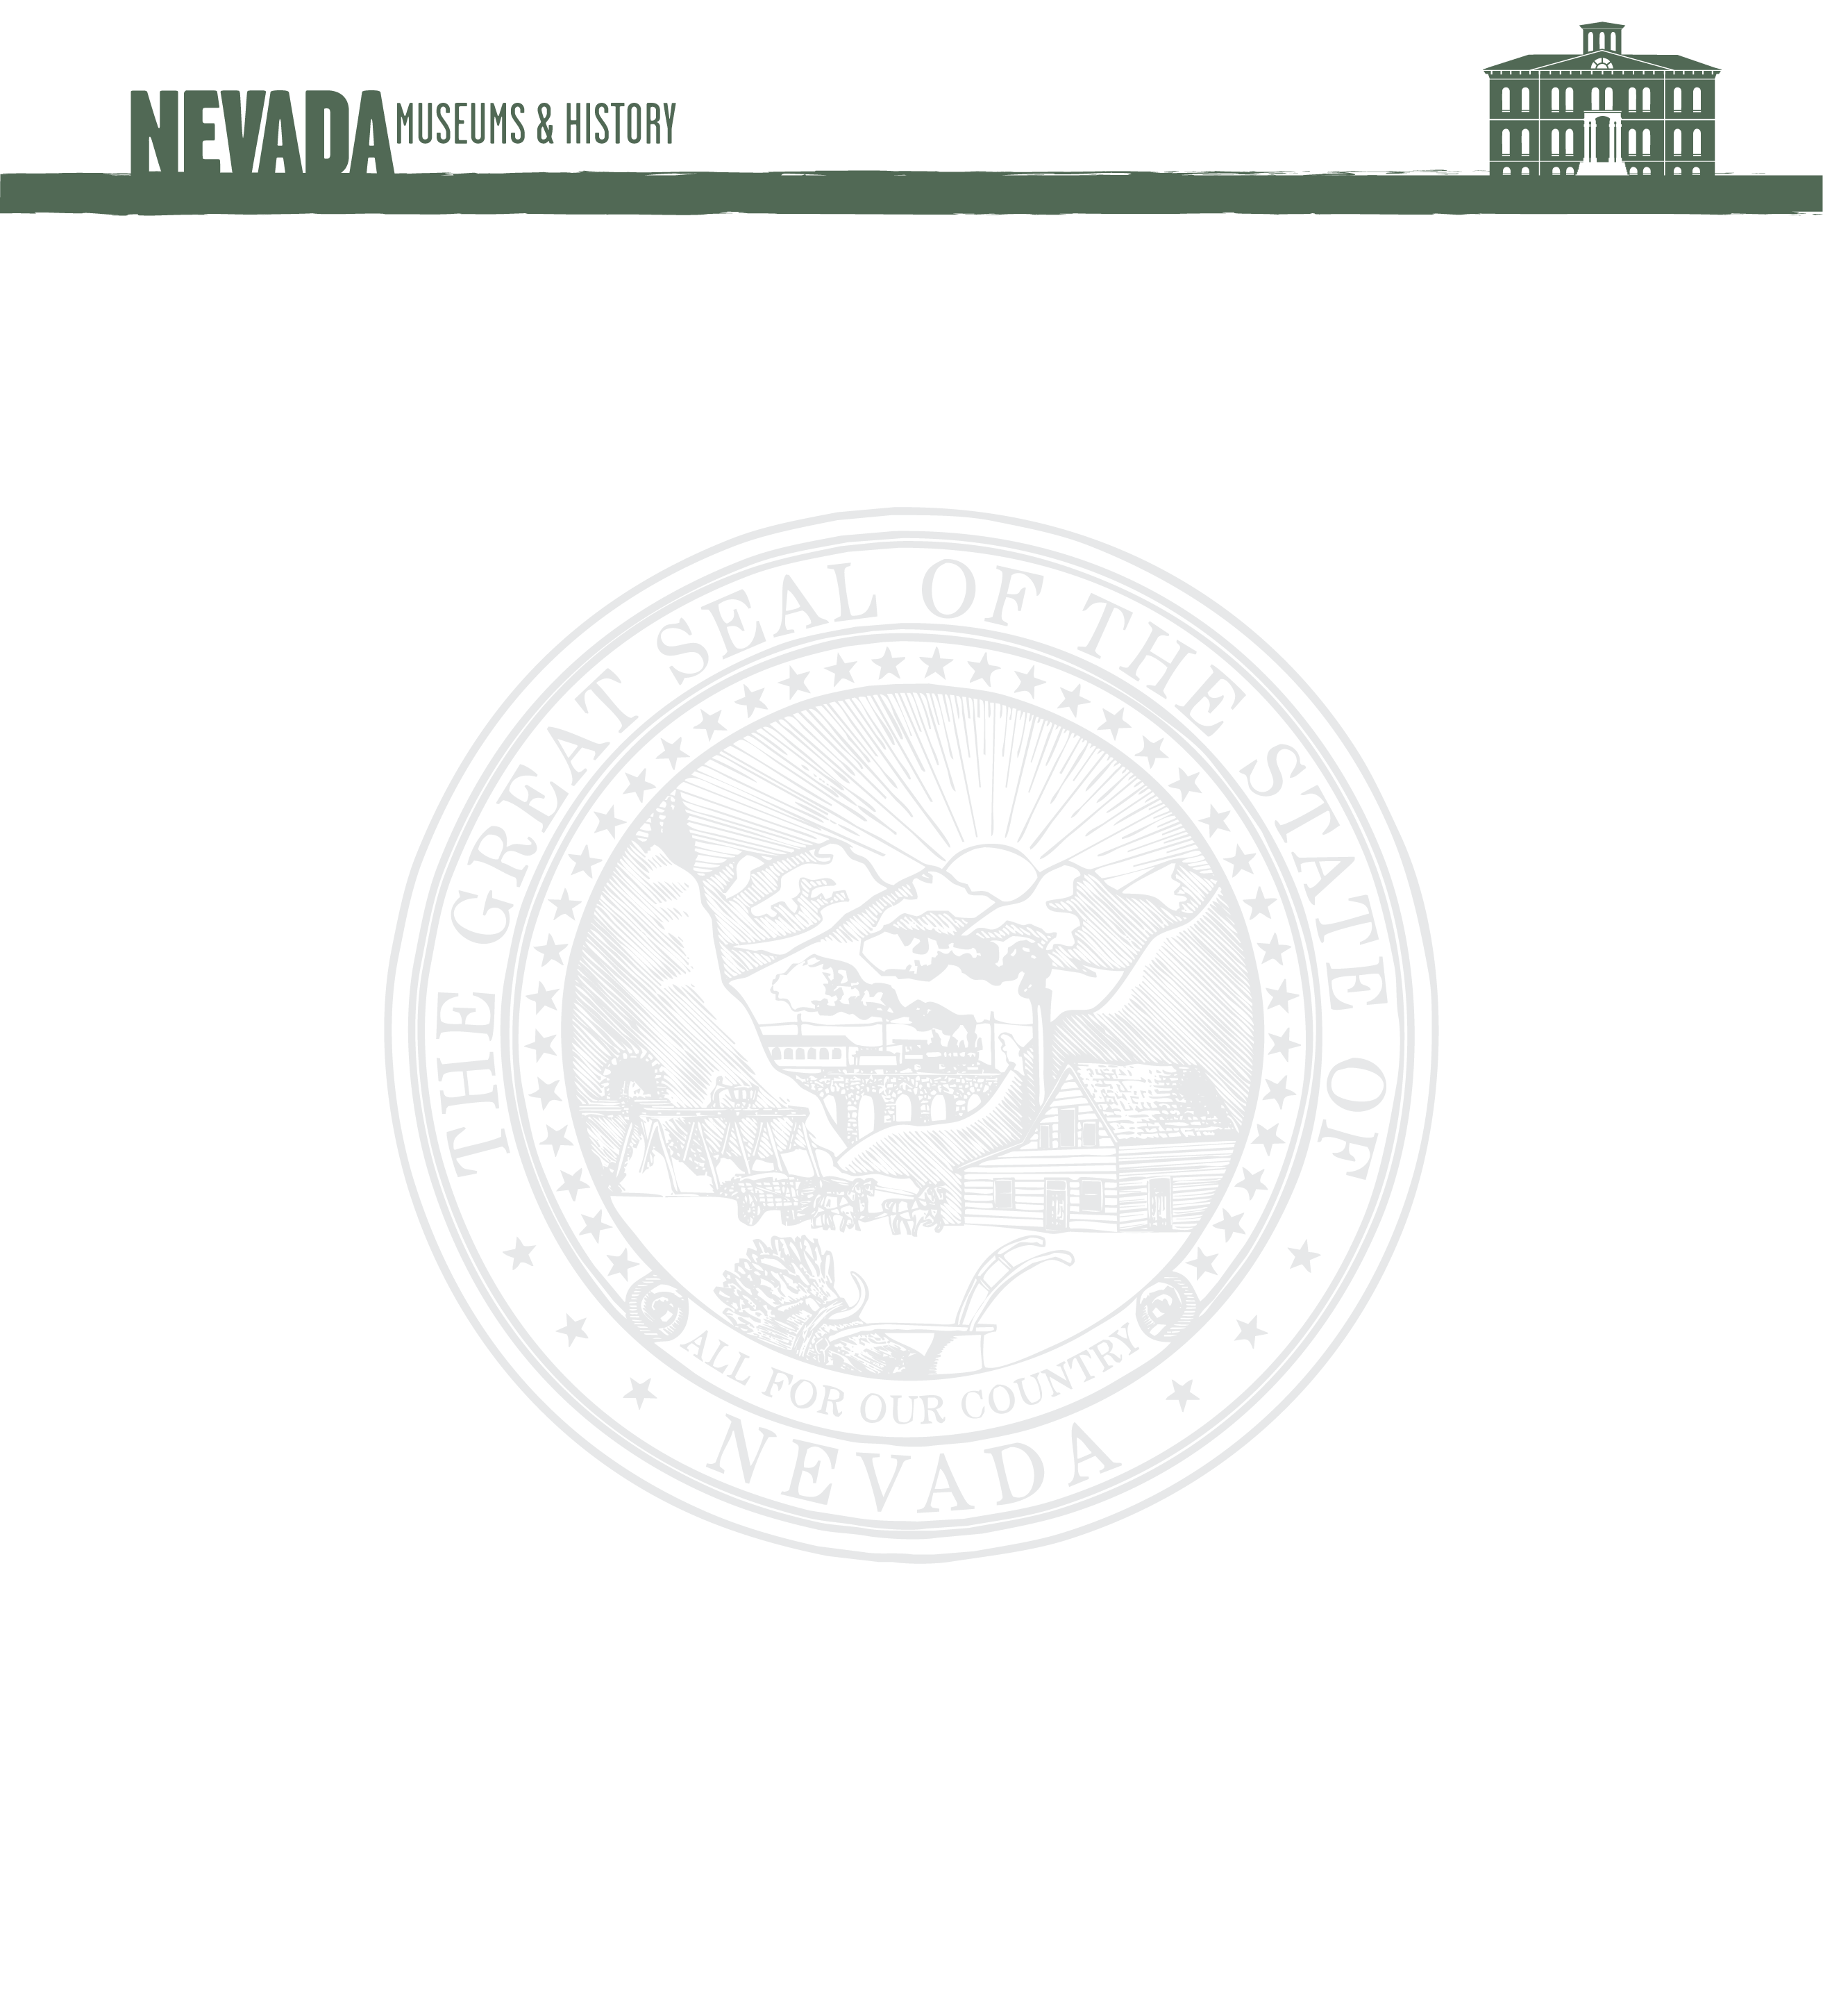
Memorandum
To: Robert Stodal, Chair, Board of Museums & History
Date: 5.29.2020
Re: John Magnusson Trust Donation

On May 21st 2020 the Nevada State Railroad Museum, Boulder City received a donation of $339,118.17 from the JRM trust, representing the estate of John Magnusson, a museum volunteer.

In discussions with his estate trustee, Barbara Maguire, and John’s sister Elizabeth Magnusson, they had expressed concern about how the funds would be cared for and used. I assured them that funds held under the state’s museum trust programs were held by the State Treasurer in a interest bearing account, under supervision of the State Board of Museums & History, exclusively for the use of NSRM-BC.

They indicated that the funds should be used for the betterment of the museum and its programs and for restoration of historic railroad equipment and specifically not to be used for site maintenance, or museum operation expenses.

Thank You, Randall Hees, Museum Director

Accepted, on behalf of the Board of Museums & History

________________________________________________________________
By Robert Stoldal, Chair

